Exercise 1

Write a C++ program for calculating grades of students.

*int main():*

* prompt user for the number of subjects for which he/she wants to calcuclate the grade 2 or 3.
* prompt for marks with respect to their early selection
* call *calgrades()* according to their selection.
  + For example calgrades(s1,s2) // for two subjects.
  + calgrades(s1,s2,s3) // for three subjects.

*Calgrades():*

* Function(s) must be overloaded accordingly.
* These functions determine the grade of student on following criteria:

A grade : 87 - 100

B grade : 75 – 86

C grade : 65 – 74

D grade : 50 – 64

F grade : < 50

**SOURCECODE:**

#include<iostream>

char Calgrades(int,int,int);

char Calgrades(int,int);

using namespace std;

int main()

{

//Declaring Variables:

int n,a,b,x,y,z;

//Enter The number on subjects:

cout<<"Enter 2 OR 3 Number of Suject For Which "

<<"You Wants To Calculate The Grades: ";

cin>>n;

//if user enter 2 then execute this block:

if(n==2)

{

//Take Obtained Marks From User:

cout<<"\nEnter The Obtained Marks in Subjects: "<<endl;

cin>>a>>b;

if(a>=1 && a<=100)

//Call Calgrades Function for 2 subjects:

cout<<Calgrades(a,b);

}

//If user enter 3 then execute this block:

if(n==3)

{

//Take Obtained Marks From User:

cout<<"\nEnter The Obtained Marks in Subjects: "<<endl;

cin>>x>>y>>z;

//Call Calgrades Function for 3 subjects:

cout<<Calgrades(x,y,z);

}

return 0;

}

//calculate Percentage then return grade for 2 values Function:

char Calgrades(int s1,int s2)

{

//Declaring Variables:

char grade;

int per,s;

//Calculatin Percentage:

s=s1+s2;

per=s*100/200;

//Use If & Else if for grades:

if(per>=87 && per<=100)

{

cout<<"\nGrade Of Student in 2 Subjects is: ";

grade='A';

}

else if(per>=75 && per<86)

{

cout<<"\nGrade Of Student in 2 Subjects is: ";

grade='B';

}

else if(per>=65 && per<74)

{

cout<<"\nGrade Of Student in 2 Subjects is: ";

grade='C';

}

else if(per>=50 && per<64)

{

cout<<"\nGrade Of Student in 2 Subjects is: ";

grade='D';

}

else if(per>=0 && per<50)

{

cout<<"\nGrade Of Student in 2 Subjects is: ";

grade='F';

}

else

cout<<"\nEnter Correct number: ";

return grade;

}

//calculate Percentage then return grade for 3 values Function:

char Calgrades(int s1,int s2,int s3)

{

//Declaring Variables:

char grade;

int per,s;

//Calculating Percentage:

s=s1+s2+s3;

per=s*100/300;

//Use If & Else if for grades:

if(per>=87 && per<=100)

{

cout<<"\nGrade Of Student in 3 Subjects is: ";

grade='A';

}

else if(per>=75 && per<86)

{

cout<<"\nGrade Of Student in 3 Subjects is: ";

grade='B';

}

else if(per>=65 && per<74)

{

cout<<"\nGrade Of Student in 3 Subjects is: ";

grade='C';

}

else if(per>=50 && per<64)

{

cout<<"\nGrade Of Student in 3 Subjects is: ";

grade='D';

}

else if(per>=0 && per<50)

{

cout<<"\nGrade Of Student in 3 Subjects is: ";

grade='F';

}

else

cout<<"\nEnter Correct number: ";

return grade;

}

**SCREENSHOT:**

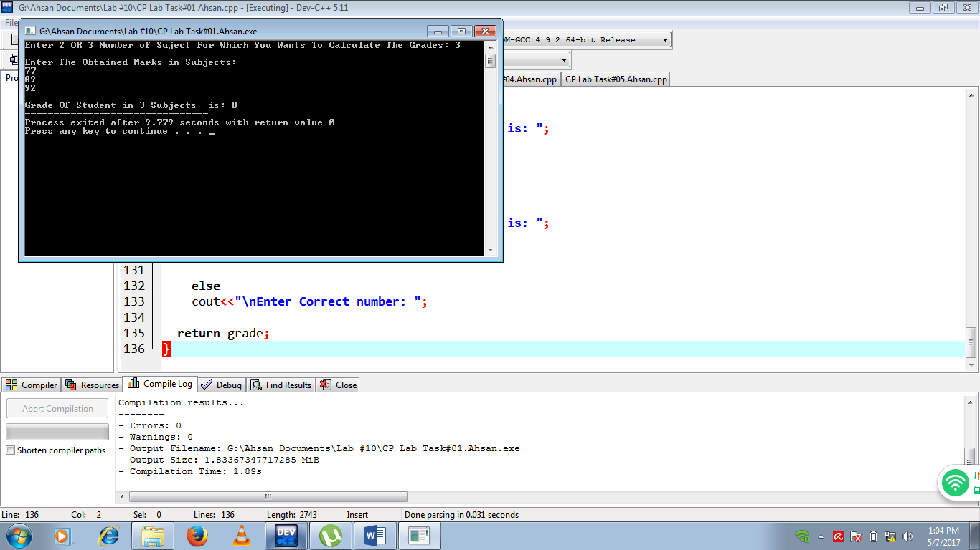

Exercise 2

Write a C++ that contains following functions:

*int main():*

* prompt user to enter numbers for comparison.
* Minimum numbers user can enter are 2 and maximum upto 4.
* call *comparison()* method with two, three and four parameters.

*int comparison():*

* this function determine the smallest and largest number
* print the smallest and largest number
* this function(s) must be overloaded

#Sample Output

Enter 4 Positive Number : 13 65 85 32

*************************************

Smallest among First two is : 13

Largest among first two is : 65

*************************************

Smallest among First three is : 13

Largest among first two is : 85

*************************************

Smallest number in the list is : 13

Largest number in the list is : 85

*************************************

**SOURCECODE:**

#include<iostream>

#include<iomanip>

using namespace std;

void comparison(int,int);

void comparison(int,int,int);

void comparison(int,int,int,int);

int main()

{

//Declaring Variables:

int a,b,c,d;

//Enter 4 number for smallest & largest comparison:

cout<<"Enter 4 Positive Numbers:"<<endl;

cin>>a>>b>>c>>d;

//use function overloading to Call Comparison function:

comparison(a,b);

comparison(a,b,c);

comparison(a,b,c,d);

return 0;

}

//Comparing Smallest And Largest Function:

void comparison(int i,int j)

{

//Use if & else if to compare Smallest & Largest values:

cout<<"\n"<<setw(63)<<setfill('*')<<endl;

if(i<j)

cout<<"\nSmallest among First Two is: "<<i<<endl;

else if(i>j)

cout<<"\nLargest Among First Two is: "<<i<<endl;

if(j<i)

cout<<"\nSmallest Among FIrst Two is: "<<j<<endl;

else if(j>i)

cout<<"\nLargest Among FIrst Two is: "<<j<<endl;

cout<<"\n"<<setw(35)<<setfill('*')<<"\n";

}

//Comparing Smallest And Largest Function:

void comparison(int i,int j,int k)

{

//Use if & else if to compare Smallest & Largest values:

cout<<"\n"<<setw(35)<<setfill('*')<<"\n";

if(k<i && k<j)

cout<<"\nSmallest Among First Three is: "<<k<<endl;

else if(k>i && k>j)

cout<<"\nLargest Among First Three is: "<<k<<endl;

if(j<i && j<k)

cout<<"\nSmallest Among First Three is: "<<j<<endl;

else if(j>i && j>k)

cout<<"\nLargest Among First Three is: "<<j<<endl;

if(i<j && i<k)

cout<<"\nSmallest Among First Three is: "<<i<<endl;

else if(i>j && i>k)

cout<<"\nLargest Among First Three is: "<<i<<endl;

cout<<"\n"<<setw(35)<<setfill('*')<<"\n";

}

//Comparing Smallest And Largest Function:

void comparison(int i,int j,int k,int l)

{

//Use if & else if to compare Smallest & Largest values:

cout<<"\n"<<setw(35)<<setfill('*')<<"\n";

if(i<j && i<k && i<l)

cout<<"\nSmallset Number in The List is: "<<i<<endl;

else if(i>j && i>k && i>l)

cout<<"\nLargest Number in The List is: "<<i<<endl;

if(j<i && j<k && j<l)

cout<<"\nSmallset Number in The List is: "<<j<<endl;

else if(j>i && j>k && j>l)

cout<<"\nLargest Number in The List is: "<<j<<endl;

if(k<i && k<j && k<l)

cout<<"\nSmallset Number in The List is: "<<k<<endl;

else if(k>i && k>j && k>l)

cout<<"\nLargest Number in The List is: "<<k<<endl;

if(l<i && l<j && l<k)

cout<<"\nSmallset Number in The List is: "<<l<<endl;

else if(l>i && l>j && l>k)

cout<<"\nLargest Number in The List is: "<<l<<endl;

cout<<"\n"<<setw(35)<<setfill('*')<<"\n";

}

**SCREENSHOT:**

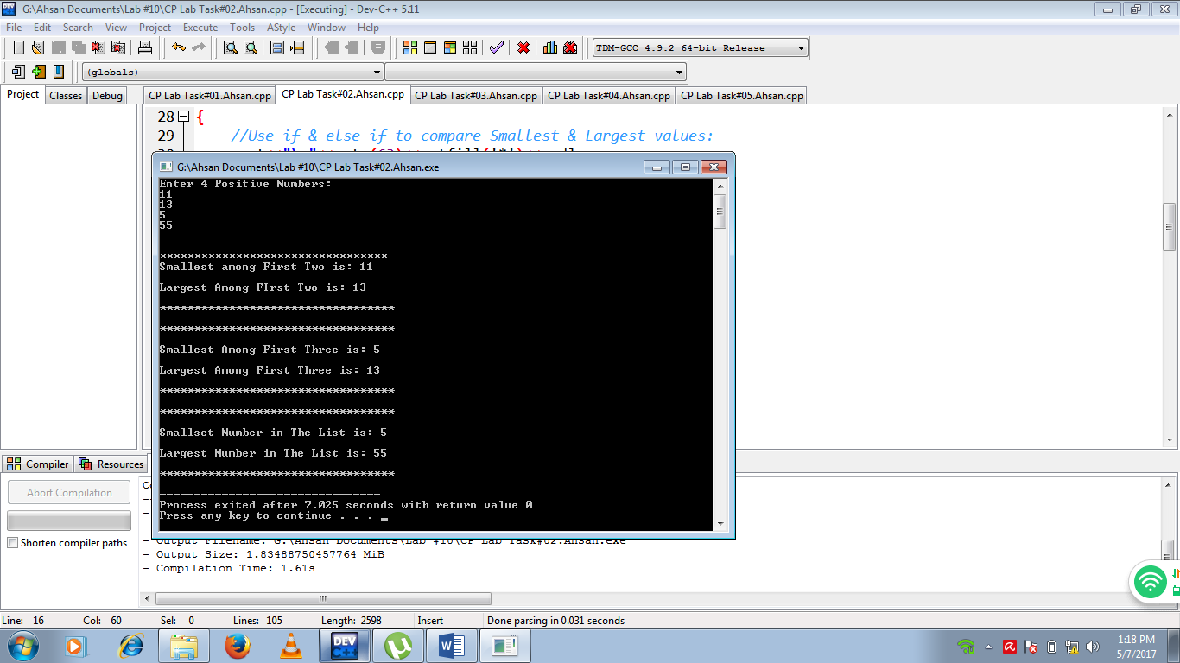

Exercise 3

Write a recursive function that prints the numbers between *1* to *n* in a reverse order.

**SOURCECODE:**

#include <iostream>

using namespace std;

int rec_func(int);

int main()

{

//Declaring Variables:

int num;

//Enter number:

cout <<"Enter any Positive Number: ";

cin >> num;

//Call rec_function to prints the recursive function in reverse order:

cout<<"\nThe Recursive function in Reverse Order is:"<<endl;

rec_func(num);

}

//Recursive function(Function Call itself):

int rec_func(int n)

{

//Use if condition tostops the recursion:

if(n==0)

return 1;

//Function call itself again & again with one lesser value:

rec_func(n-1);

//Prints function:

cout<<n<<" ";

}

**SCREENSHOT:**

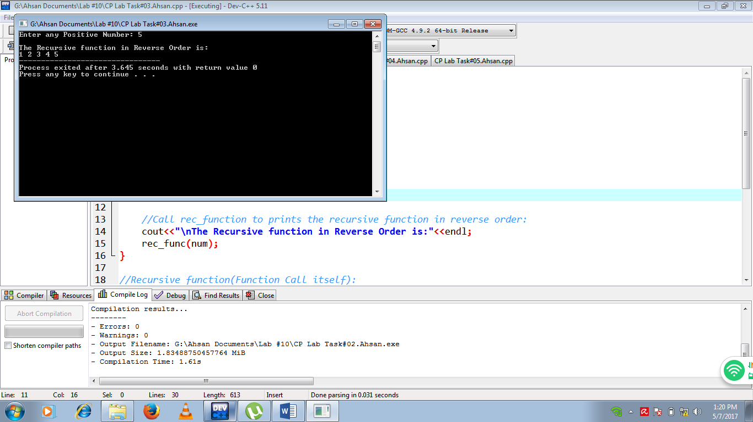

Exercise 4

Write a C++ program that perform following task:

*int main():*

* ask user to enter a positive number, store it in variable N.
* You have to calculate 1+2+3+4+……+N with fuction *int sum().*
* *Print the result.*

*int sum():*

* this function calculate the sum of series from 1 to N.
* this fuction must be recursion function.

#Sample Output

Enter a Positive number :8

Sum of Positive N(8) is : 36

**SOURCECODE:**

#include<iostream>

using namespace std;

long fact(int);

int main()

{

//Declaring Variable:

int N;

cout<<"Enter any positive number: ";

cin>>N;

//use if conditionto prints this block:

if(N>1)

{

//Call fact function:

cout<<"\nSum of Positive N("<<N<<") is: ";

cout<<fact(N);

}

return 0;

}

//Calculating factorial sum function:

long fact(int n)

{

//Use if conditionto stops the recursion:

if(n==0)

return 1;

//function call itself with one lesser value then adding it with its previous value:

return (n+fact(n-1));

}

**SCREENSHOT:**

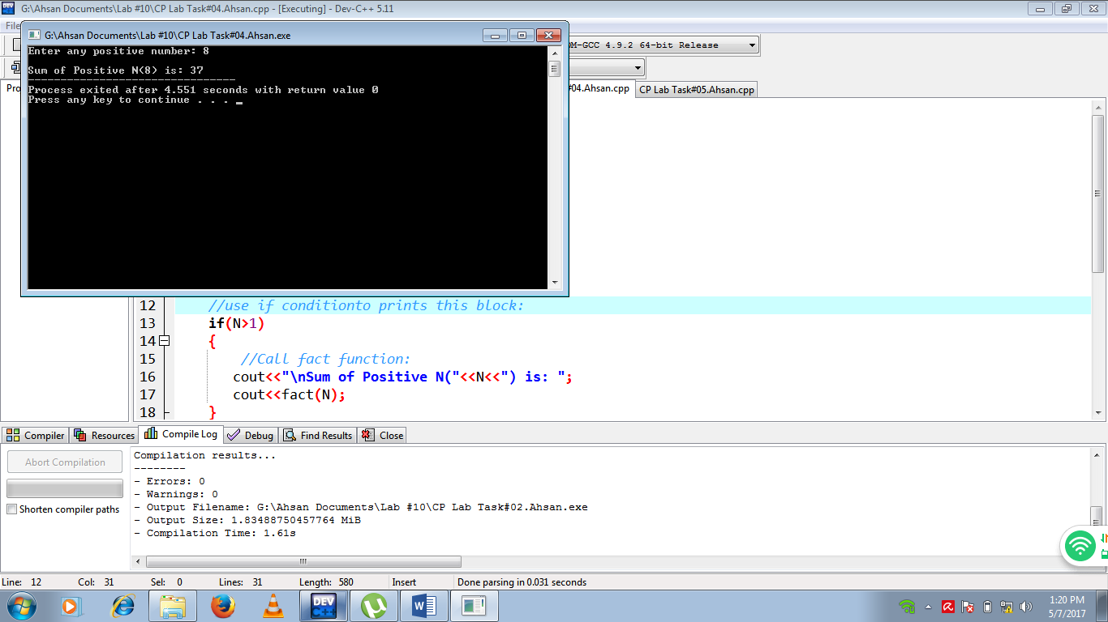

Exercise 5

Write a C++ program that perform following task:

*int main():*

* Ask user to enter a positive number, store it in variable N.
* You have to calculate Fibonacci number with fuction *int fab().*
* *Print the result.*

*int fab():*

* this function calculate the Fibonacci number.
  + 0, 1, 1, 2, 3, 5, 8, 13, 21, 34,..
  + fab(0) = 0, fab(1) = 1
  + fab(n) = fab(n-1) + fab(n-2) where n>1
* this fuction must be recursive function.

#Sample Output

Enter a Positive number :7

Fibonacci series is : 0,1,1,2,3,5,8

**SOURCECODE:**

#include<iostream>

using namespace std;

int fibonacci(int);

int main()

{

//Declaing Variables:

int n,i=0;

//Enter number :

cout<<"Input the number of terms for Fibonacci Series"<<endl;

cin>>n;

//Print Fabonacci series :

cout<<"\nFibonacci Series is: ";

//Using for loop to prints fabonacci series by call fabonacci function:

for(;i<n;i++)

{

cout<<" "<<fibonacci(i);

}

return 0;

}

//Fabonacci series function:

int fibonacci(int n)

{

//use if & else condition prints fabonacci series:

//if no is ==1 or 0 prints n:

if((n==1) || (n==0))

{

return(n);

}

//else return sum of number-1 & number-2:

else

{

return(fibonacci(n-1)+fibonacci(n-2));

}

}

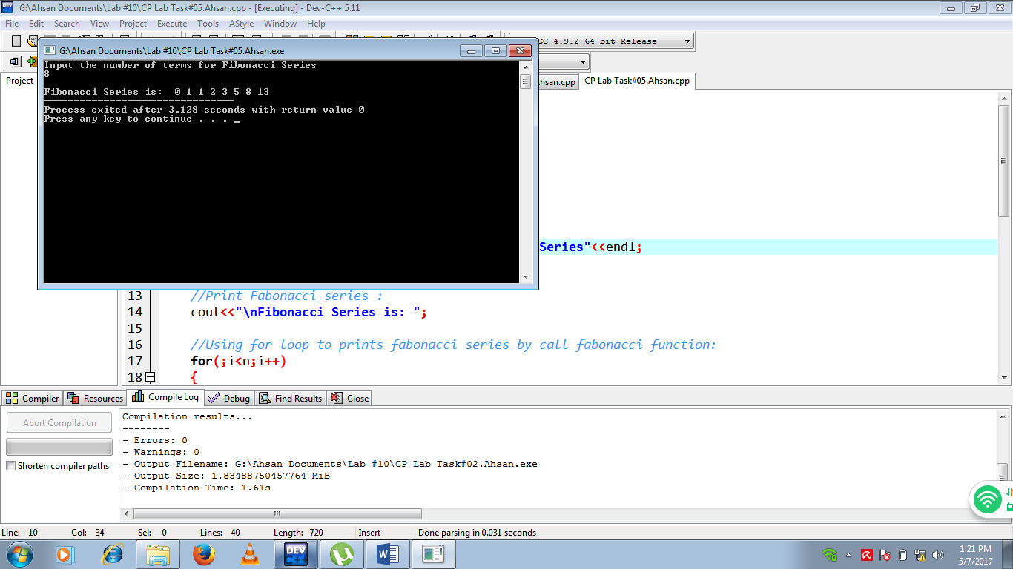**SCREENSHOT:**